Media release: Thursday 6 July 2023

Star employee scoops ‘Unsung Hero’ accolade at Cumbria Tourism Awards 2023

An up-and-coming star of the county’s tourism industry has been heralded as this year’s ‘Unsung Hero’ at the Cumbria Tourism Awards 2023.

21-year-old Ben McGregor from Lake District Estates beat off tough competition to win The Sheila Hensman Unsung Hero Award at last night’s ceremony at the Castle Green Hotel in Kendal.

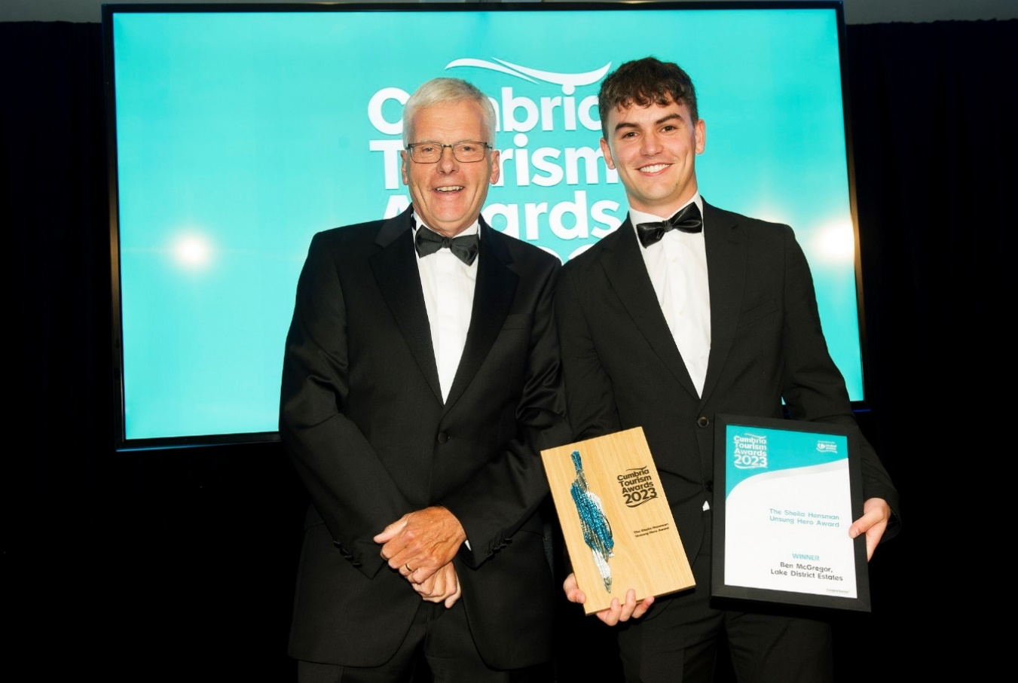

Star employee Ben joined Lake District Estates as an apprentice two years ago and has progressed to the role of Digital Marketing Coordinator. Not only does the 21-year-old show a maturity well beyond his years, but he is a true ambassador for Cumbria and has also helped the company innovate and embrace new technologies – even recently learning how to fly drones.

Alongside this, Ben is passionate about improving mental health and wellbeing for young people and his colleagues. He volunteered as a youth activist with the Young Minds charity and ran the 2023 London Marathon to raise funds. He has also recently taken up a new voluntary role as a Trustee of local mental health charity, Wave Forward, continuing to build on his experience in the topic of mental health.

At Lake District Estates, Ben works on the Being Well Together Programme with the British Safety Council and Mates in Mind charity.

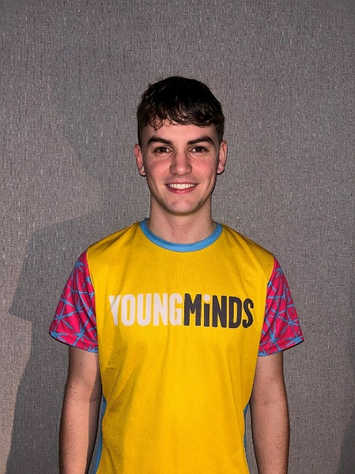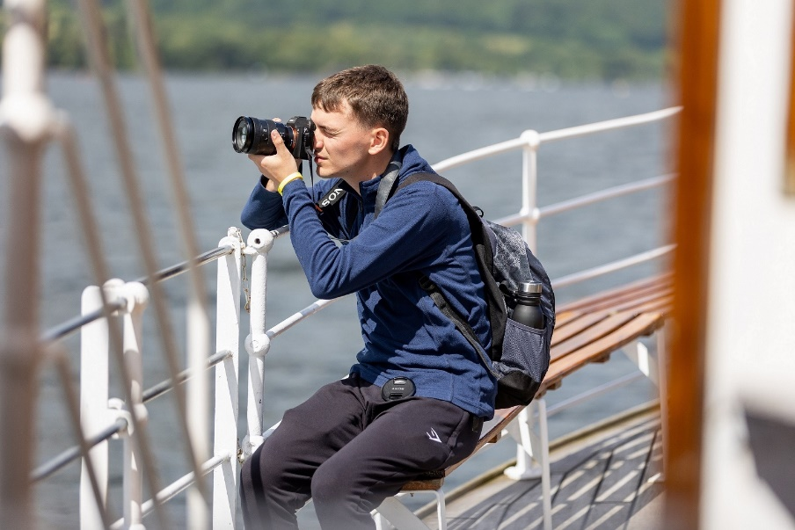

Ben says he’s over the moon to receive the accolade: “It came as a massive surprise and honour to be awarded this prestigious award, in honour of Sheila Hensman - such an influential member of the local tourism industry. I’m very lucky to work alongside such hard-working and supportive colleagues, who have helped me grow and explore my passions in the workplace and beyond”.

David Little, Chief Executive of Lake District Estates, says, “We are extremely proud of Ben McGregor, who epitomises not only a commitment and passion for showcasing the Lake District to the world, but also a positive ‘can do’ attitude to support others both in and outside the workplace”.

Lake District Estates is the homegrown family firm behind the Ravenglass & Eskdale Railway and Ullswater Steamers, alongside several caravan parks, marina holiday apartments and shops operating as ‘Peter Rabbit and Friends®’. Their online store ‘The Veg’ Patch’ has also recently opened a shop in Ambleside.

ENDS

Notes to Editors:

IMAGEs ATTACHED –

- Cumbria Tourism President Jim Walker presents the Unsung Hero award to Ben McGregor.
- Ben McGregor
- Ben at work

For further information, contact: Heather Sewell, hsewell@cumbriatourism.org / 07795 487003.

